To create a instance for backend
1)To create instance for backend (EC2 -general)
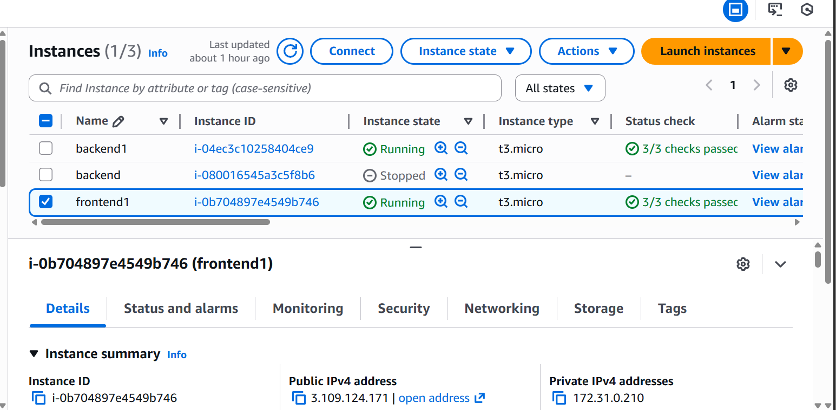
2)open ubundo using (connect) and in that ubundo server install mongodb,node.js and github(using chat gpt)
3)push our frontend code to the repository
4)then clone that repository to the front end using-git clone (repository link)
5)run the code code using following comment
-----ls
-----cd backend
-----node index.js

Output
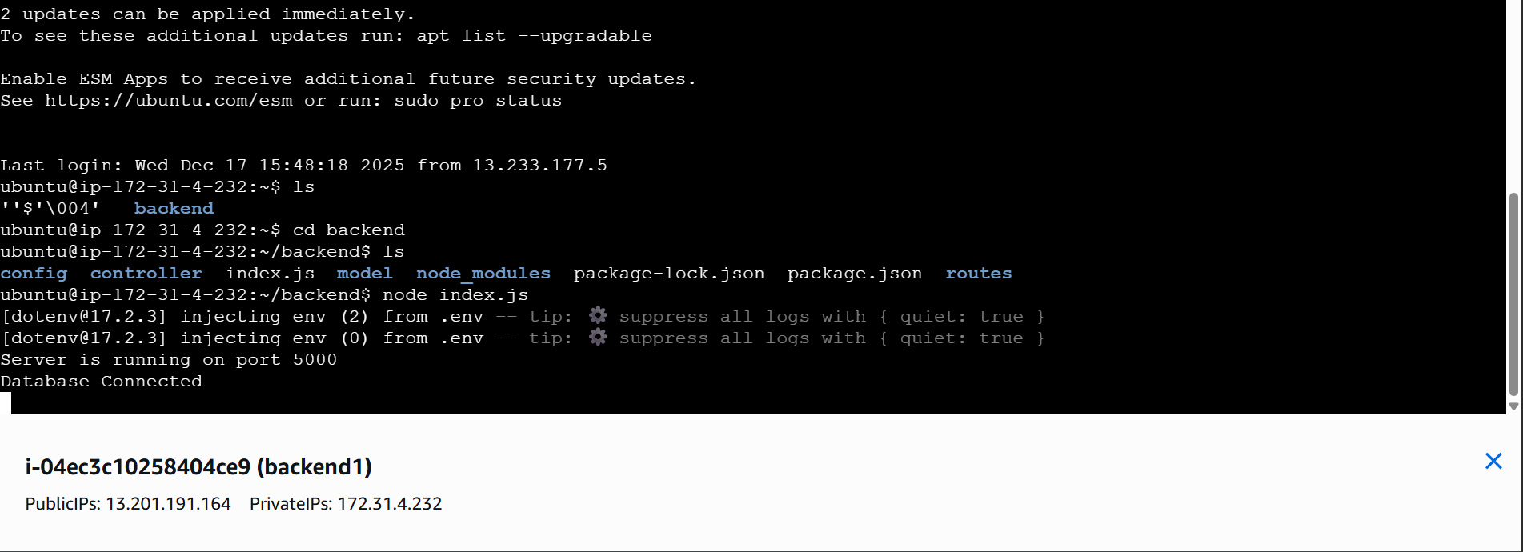

Database is connected successfully …….

To create a instance for frontend
1)to create instance for front end (EC2-general)
2)open ubundo using (connect) and in that ubundo server install node.js and github(with help of chat gpt)
3)push our backend code to the repository
4)then clone that repository to the front end using-git clone (repository link)
5)run the code code using following comment
-----ls
-----cd mernfrontend
------npm run dev
Output:
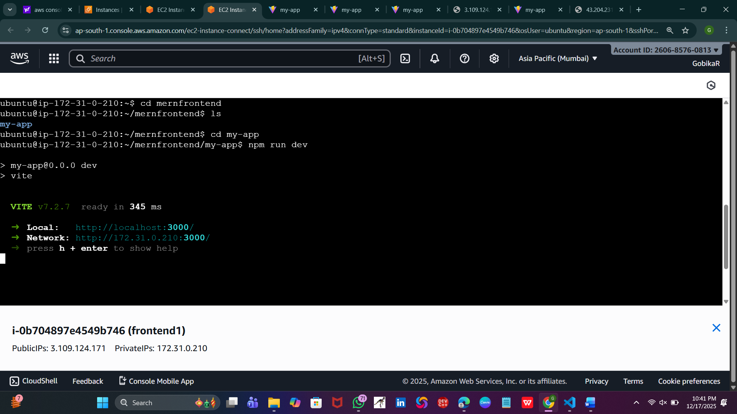

To change in url (localhost)->(public Ip address) and run in tha backend
For test the output using (postman)
For that we have to change the inbound condition in the instance

Steps for change the inbound:
-----go to back end instance
-------click the security
-------inside the security u can see the inbound
-------in that click (launch-wizard-3 )
--------click that and u have to click the security id click that and
--------click edit inbound rule
-------and then edit the port u want and change the access anywhere(0.0.0.0)
--------and then run your postman it will run successfully
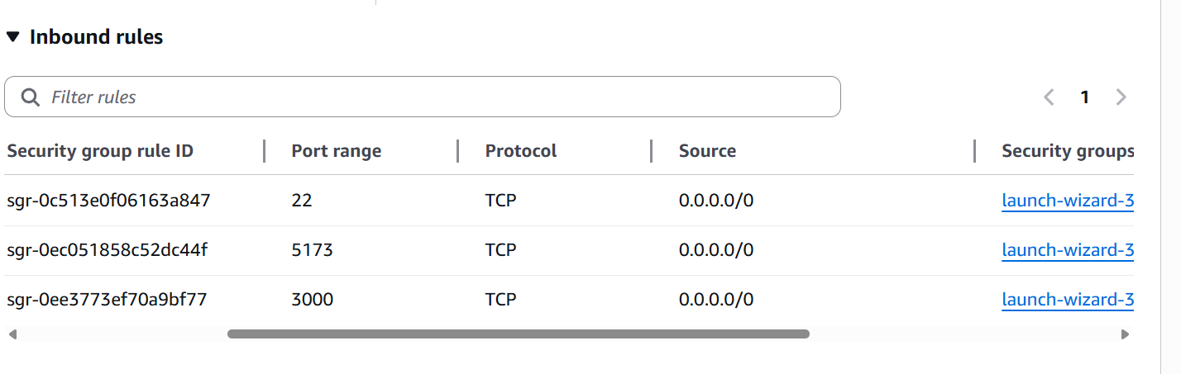

This is same for both frontend and backend(inbound)

Changes in frontend and backend code
----change the localhost inti ip addresss
1)in frontend code -server/api.js
Change the url (localhot->ip address)
2)in frontend code vite.config file change add these line
server:{
host:'0.0.0.0',
port:3000
}
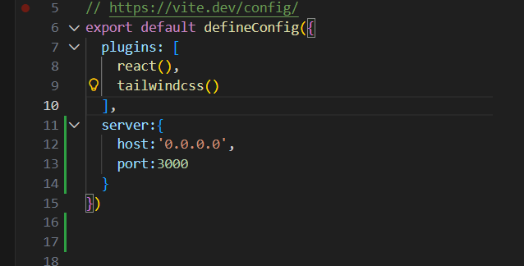

Backend deployment
For deployment we have to use some commend in backend ubunto server
----ls
----cd backend
-----ls
-----sudo install -g pm2
-----pm2 start index.js --name backend
-----pm2 save
-----pm2 startup

Frontend deployment
For deployment we have to use some commend in frontend ubunto server

-----ls
-----sudo apt install screen
-----screen -S vite
-----npm ru dev
-----ctrl+a
------ctrl+d

If u want edit the code again means
--edit file in github
----then give commit change
----then open the frontend or backend ubundo server give the bellow comment
----git pull origin main
-----ls
------npm run dev

Frontend folder structure:
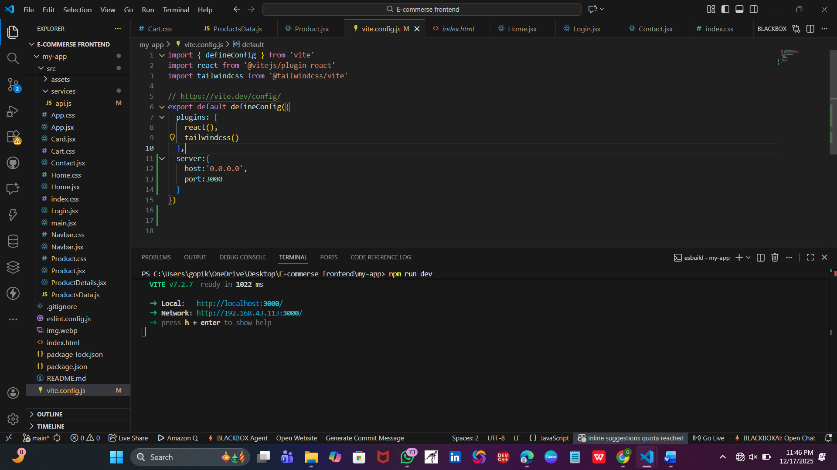

Backend folder structure:
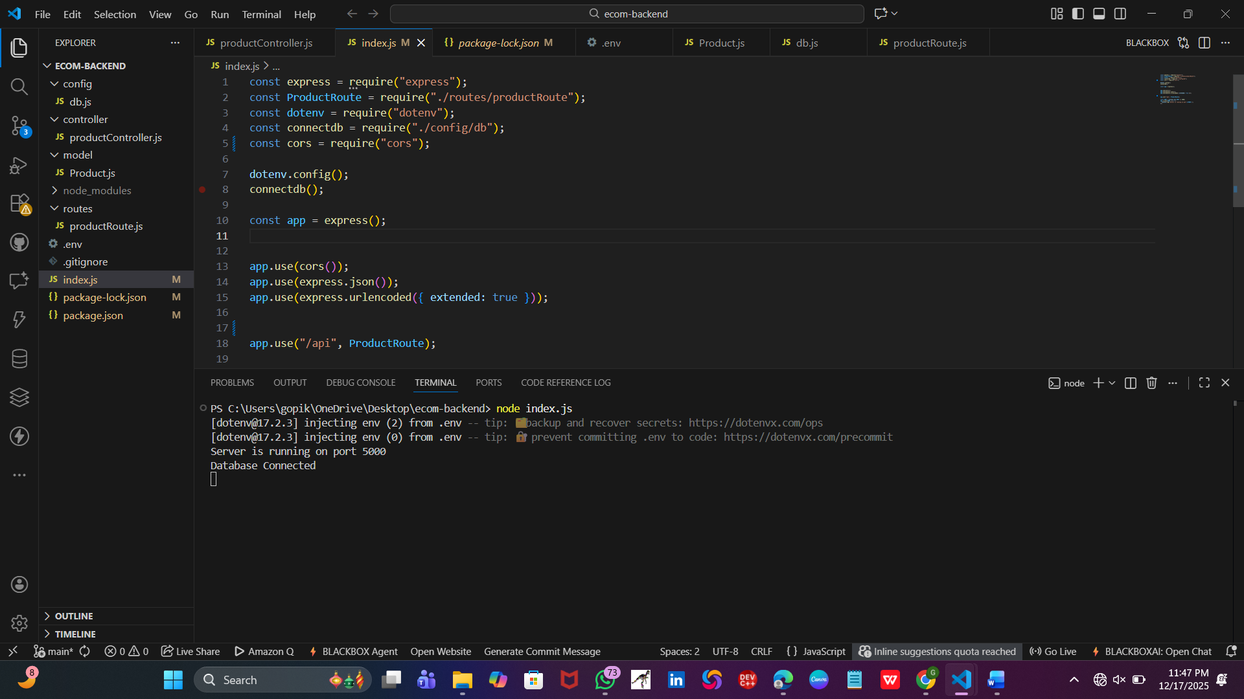

Output:


(it runs in server)

